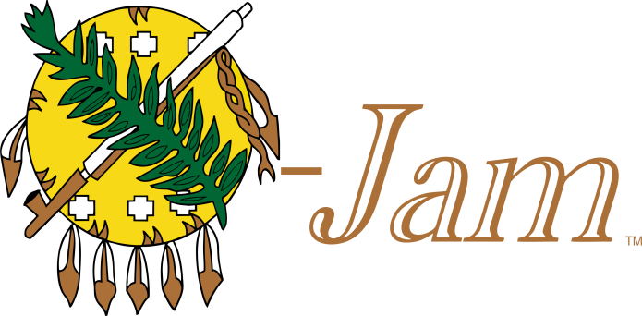
16.22 Annual Trad Camp

The 16.22 Annual
Oklahoma Selfbow
Jamboree
March 17-20, 2022
&
The 5th Annual
Ralph Conrad
Knapping Competition

Dubbed the largest rendezvous of its kind, the Oklahoma Selfbow Jamboree (OJAM) is a family-oriented event. Gates will open at 8:00 am on 3-17-2022.

Location:
Lake Carl Blackwell
11000 Oklahoma Hwy 51 West

OSS teaches the art of building a selfbow. Other primitive skills such as leatherwork and flint knapping will be on display.

Demonstrations run 8-Noon and selfbow building classes Noon-6:00 pm Thursday through Friday. A stave and OSS member-ship is required to join a class. Bow building class, the Clout Shoot, and lots of other activities on Saturday.

Limited RV sites with water and electric available. Contact Rodney Wilson @ (405)747-7776 to reserve. Tent camping $5 per night first come first serve. Restrooms and trash dumpsters on site.

Many vendors will be on site offering everything from Osage staves, to tools for building a bow, food, and even finished bows and arrows.

So, come join in on the fun and rewarding experience of building your own primitive archery equipment.
Stillwater, OK 74074

___________________________________________________________________There will also be a 3D archery course set up with $5 fun rounds or week passes available for $20.
___________________________________________________________________Go to www.okselfbow.com for more info including a map to the event.
Join us on Facebook - Oklahoma Selfbow Society-OJAM for updated information. For Vendor information contact Monty Hawkins @ (580)370-0656
___________________________________________________________________

Preserving the Heritage of Primitive Archery

